Assignment-III
- Select a simple task: "Write a Python function to check if a number is prime."
- Use different prompting strategies to generate the solution:
- Zero-Shot – no examples.
- One-Shot – one example provided.
- Few-Shot – multiple examples provided.
- Context-Managed – detailed prompt with constraints and instructions.
- Record AI responses and refine prompts to improve code quality.
- Request AI to optimize the logic for efficiency.
- Compare results and document improvements.
- Sample Prompts
- Zero-Shot:
Write a Python function to check if a number is prime.
- One-Shot:
Example: Input: 5 → Output: Prime. Now, write a function to check if a number is prime.

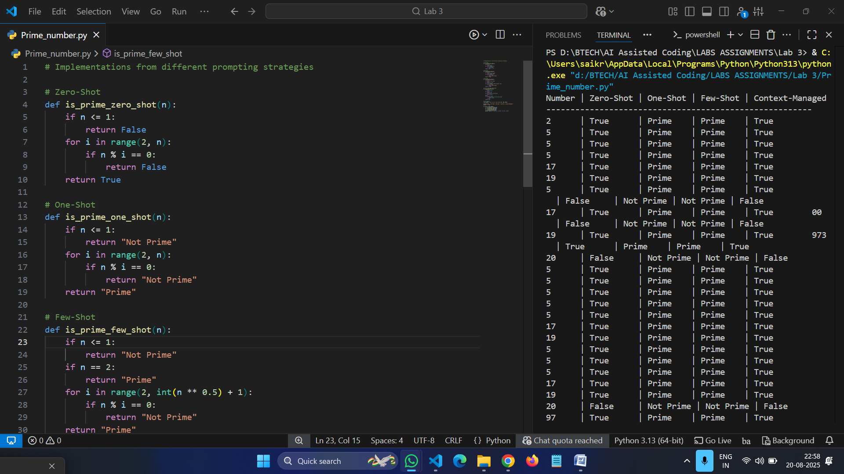

Task: Mobile Data Usage Billing Application
Objective:
Use Python programming and AI-assisted coding tools to create an application that simulates mobile data billing for a telecom service provider.
Instructions
- Use GitHub Copilot or Google Gemini to assist in writing the program.
- Read the following inputs from the user:
  - Data Consumed (in GB)
  - Plan Type (Prepaid / Postpaid)
  - Additional Services Used (e.g., caller tune, OTT subscription, etc.)
- Implement billing logic to calculate:
  - DC (Data Charges) – charges based on data consumption
  - VC (Value-added Charges) – charges for additional services
  - Tax – applicable tax on the total bill
- Display an itemized bill showing:
  - Plan Type
  - Data Usage and Charges
  - Value-added Services and Charges
  - Tax
  - Total Bill Amount
Requirements
- Students must refer to their actual mobile bill for charge structure (data cost, service fees, taxes) to make the program realistic.
- AI assistance (Copilot/Gemini) must be used to generate and refine the initial code.
Deliverables
- AI prompts used for code generation.
- AI-generated Python code and any optimized version.

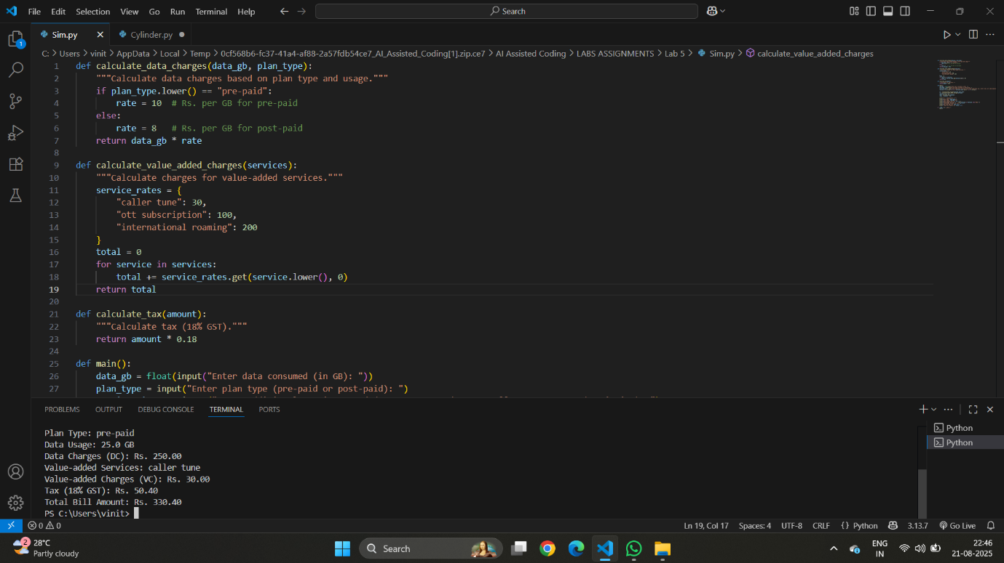

Task: Develop an LPG Billing System
Objective
Apply your Python programming skills and utilize AI-assisted coding tools to build an application that calculates the LPG bill based on specified customer inputs and billing parameters.
Instructions
- Use GitHub Copilot or Google Gemini to assist in writing and refining the program.
- Read the following user inputs:
  - Cylinder Type (Domestic 14.2 kg / Domestic 5 kg / Commercial 19 kg / Commercial 47.5 kg)
  - Number of Cylinders Booked
  - Subsidy Amount (applicable only for domestic cylinders)
- Refer to the given LPG Price List to determine the price per cylinder:
  - Domestic LPG (14.2 kg) → ₹905.00
  - Domestic LPG (5 kg) → ₹335.50
  - Commercial LPG (19 kg) → ₹1,886.50
  - Commercial LPG (47.5 kg) → ₹4,712.00
  - Delivery Charges (₹10 to ₹50)
- Implement the billing formula:
Bill Amount = (Price per Cylinder × Quantity) - Subsidy (if applicable) + Delivery Charges
- Calculate and display an itemized bill including:
- Cylinder Type
- Number of Cylinders
- Base Amount
- Subsidy
- Delivery Charges
- Total Bill Amount

